**EO MAJI**

**EO Africa explorers**

**project management plan**

V1

Date: 01/12/2022

Contract No.

**4000139395/22/I-DT**

Submitted by

|  |
| --- |
| In Cooperation with: |

**Document Release Sheet**

|  |  |  |
| --- | --- | --- |
| Author: | Héctor Nieto | Sign Date: |
| Approval | Zoltan Szantoi | Sign Date: |
| Distribution: | ESA and partners | |

**Change Record**

|  |  |  |  |  |
| --- | --- | --- | --- | --- |
| ***Version*** | ***Date*** | ***Page(s)*** | ***Change record*** | ***Release*** |
| 0 | 29/11/2022 | XX | First draft | 0.1 |
| 1 | 02/12/2022 | XX | Version submitted at KO | 1.0 |
| 2 |  |  |  |  |
| 3 |  |  |  |  |

# Introduction

## Project objective

This project aims to implement a prototype for irrigation mapping and crop yield estimation using inputs from the scientific ECOSTRESS and PRISMA missions. The final aim is to develop workflows, in collaboration with the African Early Adopters and EO partner(s), that support African irrigation and food security management, as well as transfering these R&D learnings and results to African end-users and stakeholders. More specifically the objectives in this project can overall be listed as:

* Exploration of the capabilities for future operational Copernicus missions (LSTM+CHIME) to estimate ET and crop water stress.
* Investigate the potential of PRISMA hyperspectral observations and thermal-based crop stress metrics to improve crop yield/biomass estimations to support agricultural monitoring
* Complement the ET retrievals with crop yield, in order to acquire a better understanding of water use efficiency (WUE) of cultivated landscapes.
* Direct involvement of African Early Adopters, in order to secure the usefulness and applicability of the prototype.
* Publish the findings in a freely available code repository and as scientifically peer-reviewed papers, as well as to promote the codes through other outreach activities such as development of digital notebooks.

All activities are to be carried out within the duration of the project lifetime from 1 December 2022 to 30 November 2024.

## Scope of Document

This document presents the Project Management Plan (PMP) which will be the formal, approved document used to guide both execution and control of the project “EO MAJI – EO Africa Explorers” (ESA AO/1-11038/21/I-DT).

## Reference documents

|  |  |
| --- | --- |
| REF-1 | Statement of Work: ESA-EOP-SD-SOW-0250 – EO AFRICA EXPLORERS |
| REF-2 | EO MAJI proposal dated 18/02/2022 |
| REF-3 | Clarification request from ESA dated 06/06/2022 |
| REF-4 | Response to clarification dated 22/06/2022 |
| REF-5 | Contract No. 4000139395/22/I-DT |

# Project team organization

To ensure the successful implementation of EO-MAJI, AECSIC has teamed up with DHI (Denmark) and University of Leicester (United Kingdom), two entities with proven experience with ESA, and with all required knowledge and skills for a successful project execution and completion.

AECSIC, as the prime contractor, has the full authority and responsibility to execute the project according to the signed contract and in full compliance with the requirements specified therein. As main contractor and coordinator AECSIC will be responsible for the management and controlling of the project and the coordination and communication with ESA. The official link between the agency and the project team is between the ESA Technical Officer and the AECSIC Project Manager.

The overall organisation breakdown structure with links to the project partners and associated organisations is given in Figures 1 and 2. Emphasis has been given on the complementary expertize of the partners to secure a full coverage of the project requirements. For a complete overview of the responsible partners and allocated key persons for each work package please refer to section 3.

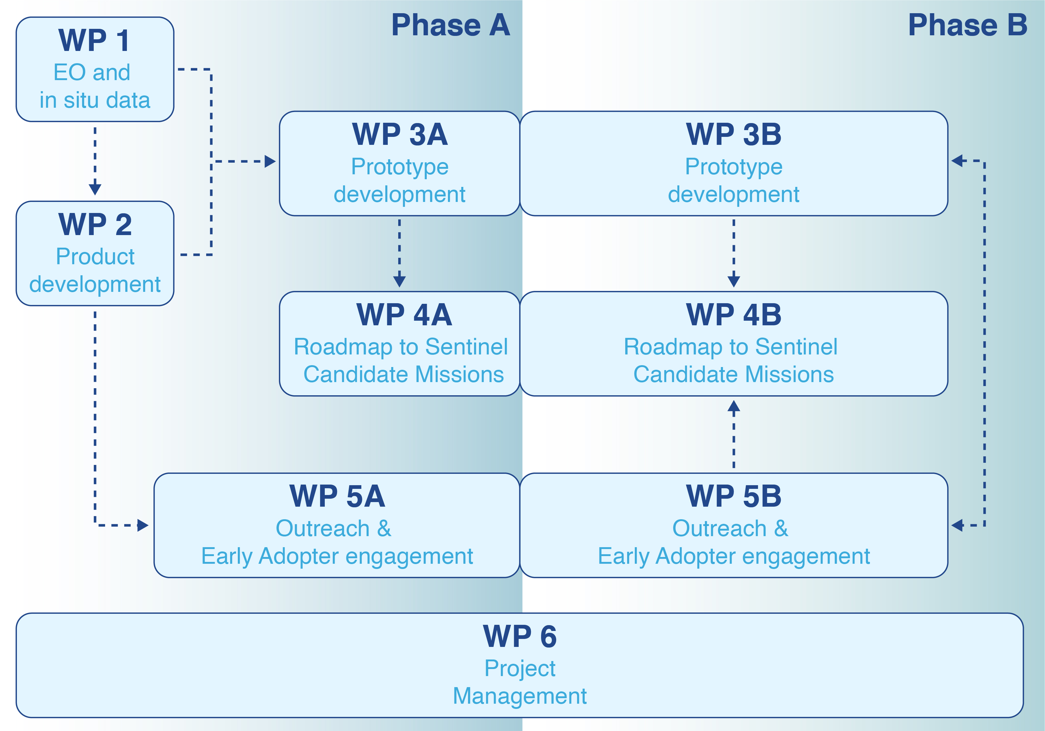Figure 1: Flowchart illustrating the worklogic indicating both phases of the project and their respective workpackages and interlinks

DHI has a extensive experience in working with local stakeholders and in developing open-source EO solutions such as Sen-ET plugin implemented for ESA-SNAP software, or the Water Observation and Information System (WOIS) plugin under TIGER-NET initiative. Additionally, they are leading researchers in the field of water resources management. For that reason, DHI will lead the first stage of the Outreach and Stakeholder Engagement (WP5A) and the Prototype Development (WP3) work packages, in addition to developing novel products in WP2.

University of Leicester (UoL ) has a long track record on land surface temperature retrievals with thermal remote sensing, and indeed developed and updated the Sentinel-3 SLSTR Land Surface Product and Algorithm. For that reason, UoL will lead the WP on EO and in situ data acquisition (WP1) as well as the dedicated work package on the roadmap to the Sentinel Candidate Missions.

All of the consortium partners have previously worked together in various ESA projects and activities and have a long established research and professional relationship. This will ensure good collaboration and efficient project execution and thus minimize project management risks and burdens.

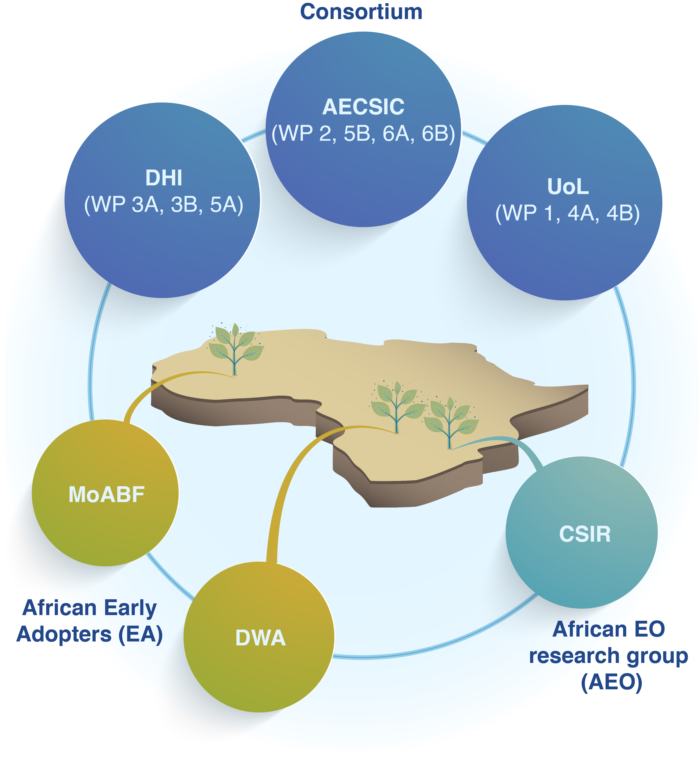Figure 2. Communication/reporting/information flow structure for the project with responsibility given on WP level. Informal communication on day-to-day matter is encouraged between WPs.

## Communication

Between AECSIC and ESA an official communication link is installed for the implementation of:

* Project direction
* Project control
* Project decision

The project information channels mainly used for communication between ESA and AECSIC are the regular progress reports, meetings and reviews.

Other contacts between the project key personnel for the purpose of transferring technical data and views, which elucidate particular problems, and in the intention to accelerate the decision making processes are foreseen. Communication in those cases will be carbon copied to the corresponding WP leaders as well to the Project Manager.

WP leaders will maintain contact with task leaders and supporting staff. Cross cutting communication is foreseen for purposes of user coordination and requirement activities. The task leaders report directly to the work package managers, providing them with sufficient authority within their organisation to direct and control the project tasks, the personnel, set priorities, and obtain the necessary resources.

For technical work packages requiring deeper involvement of several partners, direct cooperative link communication coordinated by the responsible WP manager will be used. This enables higher work efficiency and reduction of overhead costs.

Communication with the Early Adopters will be through AECSIC, as the prime, when formal correspondence is required. For less formal correspondence the partners with the strongest connection to the particular user will be the main contact. This is to ensure a continuation of the already established relationship between project partners and the associated users.

Unscheduled communication between WP leaders will be performed via e-mail and, when necessary, with bi- or multi-lateral teleconferences. In addition AECSIC provides its own teleconference platform (ConectaHa.CSIC, <https://conectaha.csic.es/b/>) that will be used for hosting both progress meetings with ESA and webinars with relevant African stakeholders.

We note in general that project partners have long and well-functioning work relations and a significant amount of informal correspondence and knowledge sharing is envisaged.

## Collaboration tools

For collaboration and document sharing, a shared online repository based on NextCloud open source tool will be made available by AECSIC ([https://saco.csic.es](https://saco.csic.es/)) with a total capacity of 100 Gb. For larger storage and data share a project SFTP site could be set up. Keeping these repositories up to date and organised in a way that makes it easy to find all relevant information is the responsibility of the project manager. In addition and to ensure consistency when communicating with Africal Early Adopters and interested parties, the Project Management also provides a set of standard templates for the various communication activities. All sharing of code will be based on GitHub, either using public or private repositories depending on the intellectual property right level.

### Project Repository

To enable efficient collaboration and document exchange, an internal project repository will be set up as a shared workspace. It is hosted and administrated by AECSIC and will be open to project partners and African Early Adopters. Parts of the repository may be shared with associated users if required. Access to the repository will be granted by the PM, after ensuring no data privacy policy is violated.

A suggested structure for the repository includes the following main content folders:

* Documents (including the main project documents and background reading/literature)
* General information (containing links to related projects and a list of abbreviations)
* Communication (containing contact details of all partners, associated users and a list of all members of SEN-ET mailing lists)
* Project planning (containing a detailed schedule of work, a list of responsibilities and open action items as well as minutes of past meetings and agendas and practical information for upcoming project meetings
* Promotion (containing information on the public web presence of EOMAJI, information on upcoming conferences, publications by the consortium, a list of dissemination activities as well as a network list of potential users)

The repository complements the project management plan and will be an online source of information on project content, progress and current status for the project consortium. It is very much a living structure and should be used and updated mainly by the Project Management, but also accessible and editable for the partners.

### Bi-monthly progress reports

A bi-monthly progress report will be submitted to ESA no later than five days after the end of each reporting period. These online meetings will be scheduled and, if possible, make them coincident with any of the milestones or delivery dates. The progress reports will document the progress of the project activities, list any closed and outstanding actions and provide a status of each active deliverable. In case of identified problems or risks this will be documented as well. Examples of specific topics relevant for the progress reporting include:

* Up to date project schedule (with a Gantt chart)
* Input Data Inventory and updates (i.e. inventory of all satellite, in-situ and ancillary data necessary for the production, calibration and validation of the EOMAJI products)
* Action Item List summary with action status
* A list of articles/papers published or accepted for publication
* A list of all events (symposiums, workshops, conferences) where the project has been presented
* Overview of scientific collaboration with other groups relevant to the project.

### SFTP site

A project secure FTP site could be setup to facilitate the sharing of large data volumes not feasible to host and distribute via the project repository.

### Templates

To ensure consistency when communicating with project stakeholders and other interested parties a set of standard templates for the various communication activities will be prepared. This includes a deliverable template, a report template, a presentation template, a poster template. A project logo will be made available by ESA. In addition, the Project Management will provide standard texts that can be used to describe the project to different audiences as well as an introductory presentation and a project leaflet.

## Sub-contractor control

The legal services of AECSIC in collaboration with the respective services at DHI and University of Leicester will handle sub-contractor agreements between the prime and the two subcontractors. Specific control measures for the sub-contractors tasks in this project are:

* Contributions to monthly progress reports – sub-contractors are requested to provide short statements describing the main activities and problems of the month.
* Sub-contractor progress meetings and technical working meetings (typically teleconferences).
* Reviews – in coordination with ESA and the users to present the preliminary and final status of the project effort,
* Action item control – done via meeting minutes. Each action item will be minuted, listed, and, in the intervening period between project meetings, will be followed up upon, with its status revised and reported upon in progress reports

### Solving of disputes

Any dispute needs solving at the appropriate level, e.g. disputes between participants in a WP should be resolved by the WP leader, and disputes between WP leaders by the project manager. If a dispute cannot be resolved at the appropriate level, the body at the next higher level will mediate and take a decision. In the case where a dispute cannot be resolved by the project team, ESA will be asked to mediate in the conflict. If this still does not solve the dispute, the project manager will prepare a solution to the dispute, this may well include reallocation of resources and tasks, and submit the proposal to ESA.

# Work Breakdown Structure

An overview of the top-level work packages (WPs) for both phases is illustrated in Figure 4. The complete work package descriptions with details to sub-activity level are found in the consortiums proposal [REF-2].

Table 1: Work Breakdown Structure (WBS). In the Contributors column, “EA” stands fo*r* the two African Early Adopters, while “AEO” *represents* the African Earth Observation research center (CSIR).

|  |  |  |  |
| --- | --- | --- | --- |
| WP | Name | Responsible | Contributors |
| 1 | Data collection and curation: EO and in situ | Darren Ghent (UoL) | DHI, AECSIC, EA, AEO |
| 2 | Product development and validation | Héctor Nieto (AECSIC) | DHI, UoL, AEO |
| 3A | Prototype development - Phase A | Radoslaw Guzinski (DHI) | AECSIC, UoL |
| 3B | Prototype development - Phase B | Radoslaw Guzinski (DHI) | AECSIC; EA, AEO |
| 4A | Roadmap to Sentinel Candidate Missions - Phase A | Darren Ghent (UoL) | DHI, AECSIC |
| 4B | Roadmap to Sentinel Candidate Missions - Phase B | Darren Ghent (UoL) | DHI, AECSIC; EA; AEO |
| 5A | Outreach & Early Adopter engagement - Phase A | Michael Munk (DHI) | AECSIC; UoL, EA, AEO |
| 5B | Outreach & Early Adopter engagement - Phase B | Vicente Burchard (AECSIC) | DHI, UoL; EA; AEO |
| 6A | Project Management - Phase A | Héctor Nieto (AECSIC) | DHI, UoL |
| 6B | Project Management - Phase B | Héctor Nieto (AECSIC) | DHI, UoL |

The allocation of responsibilities across work packages has been prioritized to accommodate the best possible use of consortium expertizes and budgets while also balancing the involvement between partners and distribute project responsibilities and deliverable assignment to secure the best possible involvement and sense of responsibility in the consortia.

The responsibilities within the consortium are as follows:

**Project Manager (Héctor Nieto)**  
The Project Manager (PM) is a senior representative of the partner. He is responsible for the overall project coordination and is the single point of contact between the ESA and the project consortium. The PM leads the project and is responsible for scientific, administrative and financial management. He keeps regular contact with the partners to ensure that the project progresses smoothly and in accordance with the SoW.

**Work Package Leaders**  
The WP leaders act as managers of their assigned Work Packages. The tasks of the WP Manager include to perform design and development work for the work packages assigned to his work package and to supervise the work of the product managers involved in the work out of the work package. The WP leaders will inform the project manager (technical and administrative) about the progress of the work package assigned to him. The WP leaders are named in Figure 4.

**Consultant’s Pool Experts**  
The responsibilities of support personnel are to perform the tasks assigned to him by the Work Package leader and to inform him/her of any difficulties which may have an influence on the execution of his task.

# Staffing plan, key personnel and assignment to tasks;

The project team consists of a group of experts with the required skills and experience needed to cover the required project tasks and secure efficient project execution fulfilling all project requirements. An overview of key personnel is given in Table 2. It should be noted that the key persons involved in the project have had excellent and continuous working relationships over the past years in various project constellations. The current and projected work load of the selected Key Experts has been duly assessed to ensure they have the capacity to provide the inputs envisaged for the project according to the time schedule and work plan as contractually agreed. The key personnel will be supported by administrative, technical and scientific staff of their respective organisations.

Table 2. Key personnel and time working on the project distributed on WP level over the project lifetime.

|  |  |  |  |  |  |  |  |  |  |  |  |  |
| --- | --- | --- | --- | --- | --- | --- | --- | --- | --- | --- | --- | --- |
| Institution | Key personnel | WORK PACKAGE | | | | | | | | | | SUM  (% FTE) |
| 1 | 2 | 3A | 3B | 4A | 4B | 5A | 5B | 6A | 6B |
| AECSIC | Héctor Nieto | 20 | 80 | 10 | 10 | 20 | 10 | 20 | 25 | 100 | 35 | 330 (10%) |
| M. Pilar Martín | 40 | 20 | 0 | 0 | 35 | 20 | 10 | 10 | 15 | 15 | 165 (5%) |
| Vicente Burchard | 190 | 1205 | 0 | 350 | 0 | 55 | 190 | 450 | 15 | 15 | 2470 (75%) |
| DHI | Radoslaw Guzinski | 25 | 70 | 120 | 100 | 20 | 20 | 10 | 30 | 20 | 20 | 435 (13 %) |
| Cécile Kittel | 0 | 52 | 80 | 0 | 0 | 0 | 10 | 30 | 0 | 0 | 172 (5%) |
| Michael Munk | 0 | 30 | 0 | 0 | 0 | 0 | 100 | 20 | 0 | 0 | 150 (5%) |
| UoL | Darren Ghent | 4 | 5 | 5 | 4 | 5 | 4 | 5 | 4 | 4 | 2 | 42 (1.3%) |
| Mike Perry | 30 | 140 | 80 | 14 | 120 | 24 | 21 | 10 | 9 | 5 | 453 (13.7%) |
|  | TOTAL | 309 | 1602 | 295 | 478 | 200 | 133 | 365 | 579 | 163 | 92 |  |

# Project schedule

The prepared Gantt chart for managing the project activities (Figure 3) summarizes the project schedule in terms of time spans for the proposed work packages, completion dates of necessary deliverables as well as dates of proposed meetings.

As part of the first project management tasks the prepared Gantt will be implemented in the Project Management Plan (PMP), and hereafter updated throughout the project lifetime in response to the Bi-monthly Progress Reports or as needed.

Figure 3: Gantt chart showing the project master schedule. Each color in the chart represents the work package leader: Grey, AECSIC; Blue, DHI; Red, UoL

|  |  |  |  |  |  |  |  |  |  |  |  |  |  |  |  |  |  |  |  |  |  |  |  |  |
| --- | --- | --- | --- | --- | --- | --- | --- | --- | --- | --- | --- | --- | --- | --- | --- | --- | --- | --- | --- | --- | --- | --- | --- | --- |
|  | Phase A | | | | | | | | | | | | | | | | | | Phase B | | | | | |
| Year | ‘22 | ‘23 | | | | | | | | | | | | ‘24 | | | | | | | | | | |
| Month  Milestone (MS) | Dec | Jan | Feb | Mar  MS1 | Apr | May | Jun | Jul | Ago | Sep | Oct | Nov | Dec | Jan | Feb | Mar | Apr | May  MS2 | Jun | Jul | Ago | Sep | Oct  MS3 | Nov  MS4 |
| WP 1 |  |  |  |  |  |  |  |  |  |  |  |  |  |  |  |  |  |  |  |  |  |  |  |  |
| WP 2 |  |  |  | **D03**  **D06** |  |  |  |  |  |  |  |  |  |  |  |  |  | **D06**  **D07** |  |  |  |  |  |  |
| WP 3A |  |  |  | **D05** |  |  |  |  |  |  |  |  |  |  |  |  |  | **D08** |  |  |  |  |  |  |
| WP 4A |  |  |  | **D04** |  |  |  |  |  |  |  |  |  |  |  |  |  |  |  |  |  |  |  |  |
| WP 5A | **D01** |  |  | **D02** | **D17** |  |  |  |  |  |  |  |  |  |  | **D10** |  |  |  |  |  |  |  |  |
| WP 6A | **D12**  **D15** | **D12**  **D13** |  | **D12**  **D13** |  | **D12**  **D13** |  | **D12**  **D13** |  | **D12**  **D13** |  | **D12**  **D13** |  | **D12**  **D13** |  | **D12**  **D13** |  | **D12**  **D13** |  |  |  |  |  |  |
| WP 3B |  |  |  |  |  |  |  |  |  |  |  |  |  |  |  |  |  |  | **D05** | **D05** | **D05** | **D05** | **D05**  **D06**  **D08**  **D09**  **D16** | **D05** |
| WP 4B |  |  |  |  |  |  |  |  |  |  |  |  |  |  |  |  |  |  |  |  |  |  | **D11**  **D18** |  |
| WP 5B |  |  |  |  |  |  |  |  |  |  |  |  |  |  |  |  |  |  |  |  |  | **D10** | **D17** |  |
| WP 6B |  |  |  |  |  |  |  |  |  |  |  |  |  |  |  |  |  |  |  | **D12**  **D13** |  | **D12**  **D13** |  | **D12**  **D13**  **D19**  **D20**  **D21**  **D22** |

Table 3: Full meeting and travel plan for EOMAJI with stated purpose and deliverable review schedule indicated.

|  |  |  |  |  |
| --- | --- | --- | --- | --- |
| **Name** | **Date** | **Purpose** | **Participants** | **Location** |
| KOM | KO+0 | **Kick-off meeting**  Review of D01 & D15 | Consortium, ESA | Teleconference |
| PM1 | KO+2 | Progress Meeting 1 | Consortium, ESA | Teleconference |
| MS1 | KO+4 | **Milestone 1**  Review of D02, D03, D04, D05 & D06 | Consortium, ESA, EAs | ESRIN (IT) |
| PM2 | KO+6 | **Progress Meeting 2** | Consortium, ESA | Teleconference |
| PM3 | KO+8 | **Progress Meeting 3** | Consortium, ESA | Teleconference |
| PM4 | KO+10 | **Progress Meeting 4** | Consortium, ESA | Teleconference |
| PM5 | KO+12 | **Progress Meeting 5** | Consortium, ESA | Teleconference |
| PM6 | KO+14 | **Progress Meeting 6** | Consortium, ESA | Teleconference |
| PM7 | KO+16 | **Progress Meeting 7**  Review of D10 | Consortium, ESA | Teleconference |
| MS2 | KO+18 | **Milestone 2: End of Phase A**  Review of Phase A and D06, D07 & D08 | Consortium, ESA, EAs | ESRIN (IT) |
| PM8 | KO+20 | **Progress Meeting 8**  Review of D05 | Consortium, ESA | Teleconference |
| PM10 | KO+22 | **Progress Meeting 10**  Review of D05 & D10 | Consortium, ESA | Teleconference |
| MS3 | KO+23 | **Milestone 3: End of Phase B**  Review of D05, D06, D07, D08, D09, D11, D16, D17 & D18 | Consortium, ESA, EAs | Gaborone (BW) |
| MS4 | KO+24 | **Final meeting**  Review of project and D05, D12, D13 D19, D20, D21 & D22 | Consortium, ESA, EAs | ESRIN (IT) |

# Project deliverables

An overview of deliverables is given in Table 4, which complies with the requirements in the Statement of Work. All documents to be reviewed at progress/review meetings will be delivered to ESA at least two weeks (or 10 working days), prior to the meeting (REQ-42). Any comments and/or clarifications arising from the review meeting, including ESA RIDs, will be addressed, and the updated document resubmitted to ESA within 1 month.

Table 4: List of Deliverables, with expected delivery date, type of deliverable and responsible.

|  |  |  |  |  |
| --- | --- | --- | --- | --- |
| **Deliverable** | | **Due Date** | **Type** | **Responsible** |
| **D01** | Collaboration descriptions with African EAs and the African EO research group/s. | KO | Doc | DHI |
| **D02** | African EAs characterisation and benefit analysis report | KO+4 (M1) | Doc | DHI |
| **D03** | State-of-the-art review report on the EO analysis method/s and algorithm/s | KO+4 (M1) | Doc | AECSIC |
| **D04** | Policy Traceability Matrix analysis | KO+4 (M1) | Doc | UoL |
| **D05** | Agile Development Plan  Agile Development Progress reports | KO+4 (M1)  Monthly after KO+18 (M3) | Doc | DHI |
| **D06** | Validation Methodology  Validation data  Validation final report | KO+4 (M1)  KO+18 (M2)  KO+18 & KO+23 (M3) | Doc  DB  Doc | UoL |
| **D07** | ATBD/s and products specifications | KO+18 (M2) & KO+23 (M3) | Doc | AECSIC |
| **D08** | Associated documentation of processor/toolbox/software | KO+18 (M2) & KO+23 (M3) | Doc | DHI |
| **D09** | Prototype test | KO + 23 (M3) | Doc | DHI |
| **D10** | Webinars | KO + 23 (M3) | Record | AECSIC |
| **D11** | Policy Highlights | As necessary | Doc | UoL |
| **D12** | Minutes of Meetings | As necessary | Doc | AECSIC |
| **D13** | Progress reports | Bi-monthly | Doc | AECSIC |
| **D14** | Problem notification and analysis | As necessary | Doc | AECSIC |
| **D15** | Project Management Plan | KO | Doc | AECSIC |
| **D16** | Report on the integration into a platform environment of the developed software and related output products/indicators | KO+23 (M3) | Doc | DHI |
| **D17** | Communications website | KO+4 (M1) | Web | AECSIC |
| **D18** | Potentials and limitations analysis for CHIME & LSTM | KO+18 (M2) & KO+23 (M3) | Doc | UoL |
| **D19** | Final presentation and Executive Summary | KO+24 (M4) | Doc | AECSIC |
| **D20** | Contract Closure Documentation | KO+24 (M4) | Doc | AECSIC |
| **D21** | Scientific Publications | KO+24 (M4) | Doc | AECSIC |
| **D22** | Capacity building material | KO+24 (M4) | Jupyter notebook | AECSIC |

## Naming of deliverables

All document deliverables will be named after the following nomenclature:

EOMAJI_<DeliverableNº>_<Code>_< Version>

e.g.: EOMAJI_D15_PMP_v0.1.docx for the Project Management Plan in version 0.1.

# List of Customer Furnished Items (CFIs)

At project start there are no project CFIs. This section will be updated as needed.

# Travel plan and budget

The proposed schedule for review meetings with ESA and Early Adopters during that period is in line with the SoW – details are presented in Table 5.

It should be noted that for estimating travel costs partners regular travel policy has been followed along with realistic cost estimates based on economy travels. Per-diem are computed from the official rates for each partner and depending on the country of destination. Travels and subsistence for EAs and the African EO R+D partners will be covered by the Prime contractor (AECSIC) using the official rates appointed by the Spanish Royal Decree RD 462/2002 (<https://www.boe.es/buscar/pdf/2002/BOE-A-2002-10337-consolidado.pdf>).

The M.1, M.2 and M.4 will take place at ESA ESRIN (Covid-19-related conditions permitting) with the presence of key representatives from the African Early Adopters and EO research involved in the project. The M.3 (Acceptance of Task-B) meeting shall take place in Gaborone (Botswana) with the presence of the ESA TO. The M.4 Final Presentation shall take place just before the Contract closure.

Table 5: Travel plan. Participates in bold font will be covered (at least one representative) by the travel and subsistence plan (see corresponding Exhibits B in ANNEX 2)

|  |  |  |  |  |
| --- | --- | --- | --- | --- |
| Name | Date | Purpose | Participants | Location |
| M1 | KO+4 | Acceptance of Milestone 1 | **AECSIC, DHI, UoL,** ESA | ESRIN (IT) |
| M2 | KO+18 | Acceptance of Task A | **AECSIC, DHI, UoL, CSIR, MoABF, DWA,** ESA | ESRIN (IT) |
| M3 | KO+23 | Acceptance of Task B | **AECSIC, DHI, UoL, CSIR, MoABF, DWA,** ESA | Gaborone (BW) |
| M4 | KO+24 | Final Presentation | **AECSIC, DHI, UoL, CSIR, MoABF, DWA,** ESA | ESRIN (IT) |

# Risk management plan

We have identified the following problem areas or issues with regard to the implementation of EOMAJI. Each problem area has been subject to an evaluation with regard to probability and impact (Table 6) as well as proposed mitigation procedure.

Table 6: Contingency table describing possible risks and mitigation actions

|  |  |  |  |
| --- | --- | --- | --- |
| Risk | Probability | Impact | Mitigation action |
| Low image availability due to cloud coverage | High | Medium | Data fusion with other satellites |
| Lack of past and future ECOSTRESS and PRISMA acquisitions | Medium | High | Careful selection of study areas. Identification of missions which could function as proxies of ECOSTRESS and PRISMA |
| Lack of in-situ data for validation | Medium | Medium | Early discussion with African partners regarding field data availability. Inclusion of well-instrumented sites with optimal series of in.situ data available outside of Africa for validation. |
| Political instability in Burkina Faso | Medium | Low | Identification of additional Early Adopters in west Africa. |

1. Cloud coverage. Some of the areas of interest can be impacted by seasonally persistent cloud coverage, hampering the availability of EO optical data. This is particularly relevant in missions with less frequent repeating cycles or with non-systematic acquisitions.
2. Infrequent historical and inability to task future ECOSTRESS/PRISMA acquisitions. We conducted a preliminary survey on available imagery in areas of interest by our Early Adopters and beyond, and in particular for PRISMA there is quite scarce available data. In addition, tasking of future acquisitions might be difficult due technical issues and already existing tasking commitments.
3. Lack of in situ data for validation. In order to validate the algorithm and prototype that will be developed, yield and ET/irrigation data are needed, which might be difficult to access. MoABF has already provided us with some yield for several rice fields in two different areas for the agronomic years 2019 and 2020.
4. Political instability in Burkina Faso. The recent events occurring in Burkina Faso, with a military coup on 23 January 2022, might cause an impossibility for its Ministry of Agriculture to effectively collaborate in the planned activities.

Based on the main problems identified, we foresee the following solutions:

1. Cloud coverage. Data fusion with Sentinel-2 and Sentinel-3, as well as ET gap filling techniques, will be implemented in cloudy conditions. The consortium has a wide and successful experience in sharpening Sentinel data to produce daily ET estimates at field scale (e.g. SEN-ET and ET4FAO ESA EO Science for Society projects).
2. Infrequent historical ECOSTRESS/PRISMA acquisitions. We have selected our African partners partly based on availability of historical ECOSTRESS/PRISMA acquisitions in their areas of interest. Historical Sentinel-2 data will be used to complement PRISMA data, whereas Landsat 8 and 9 will substitute ECOSTRESS imagery when any of these dataset were missing. Historical hyperspectral data could be used from *ad hoc* airborne campaigns such as HYPLANT 2018 and AVIRIS-NG 2021, which could be used to simulate PRISMA imagery. In addition we will explore the potential of using other novel sensors as a replacement for tasked ECOSTRESS (e.g. LisR of ISS and HiVE micro-satellites from ConstellR - see Letter of Support in Annex 3) and PRISMA (DESIS on ISS and EnMAP satellite from DLR) acquisitions.
3. Lack of in situ data for validation. As mentioned previously MoABF has already provided us with some yield for several rice fields in two different areas, and they are exploring additional data from surveys conducted by technicians. In addition, CSIR in collaboration with the University of Pretoria are evaluating the availability of historical crop data in experimental sites. Nevertheless, during the algorithm development and validation phase (phase A of the ITT) we will consider other sites outside Africa, but with similar climatology, with long-term record of in situ measurements, such as Majadas de Tiétar FLUXNET/ICOS site and/or Barrax experimental farm, both in Spain.
4. Political instability in Burkina Faso. By the time of the project Kick-Off it is possible that the political situation in Burkina Faso would be normalized again. However, if that is not the case, we foresee contacting other Early Adopter candidates in the West Africa region (e.g. AGRHYMET) to include them before the Kick-Off.

# Quality assurance

All activities of AECSIC are conducted in accordance with internationally accepted principles for quality management.

## Quality assurance plan

The Project Management Team will prepare a self-contained Quality Assurance Plan (QAP) describing the procedures to be applied by all Team Members to ensure the quality of the services to be rendered, and to define the responsibility and authority of all key personnel within the organisation. The responsibility for the implementation of the QAP is with the Project Manager. Quality assurance is the responsibility of all team members, who will be familiar with the plan and comply with the procedures. Quality control and adherence to the quality procedures will be reviewed periodically by the Home Office Backup and Quality Control Officer and findings and recommendations will be reported to the Project Manager

## Quality assurance by the project management

The day-to-day management of the project is the responsibility of the Project Manager. Among the duties of project management related to quality assurance are:

* Ensure all team members are familiar with the general procedures, and quality assurance procedures
* Ensure any external participants are aware of the quality assurance procedures
* Assist all team members in the implementation of the quality assurance procedures
* Administration of the quality assurance procedures
* Cooperation with the Quality Assurance staff member in inspecting the quality assurance procedures
* Implementation of the recommendations of the Quality Assurance staff member.

In order to ensure proper planning, coordination and compliance with established procedures, all formal communication with ESA and project participants will be passed through the Project Manager. This should not limit the informal exchange of information and ideas among all project participants, which should take place in an open spirit working towards a common goal.

For all formal meetings arranged by the project, an agenda will be prepared along with a brief note describing the background to the agenda items, and the issues expected to be discussed and resolved. This will be distributed in advance to all participants in the meeting. The participants should arrive at the meeting informed and prepared to make a positive contribution to the discussion and the resolutions.

# Promotion and Dissemination Plan

We will pay particular attention to the promotion and outreach activities, as they are a very important for the uptake of EOMAJI outcomes.

We will prepare, implement and maintain an informal promotion/dissemination plan on the Project repository as a track record of all completed and upcoming activities related to the key activities as described below in section 11.1 to 11.3.

## Project Web Site

A project web site will be established under WP5 – Outreach activities and Early Adopters engagement, briefly outlining the background of EOMAJI and relevant background and supporting information.

The content inputs for the website will be developed by the consortium and where relevant with inputs from all involved parties (incl. the users) under leadership of DHI. The preliminary design of the website foresee the hosting of the following content:

ABOUT: the project information section, including sub-pages on:

* + PARTNERS: An information sheet on the EOMAJI consortium
  + AFRICAN EARLY ADOPTERS: An information sheet on the EOMAJI African users

SOFTWARE

CONTACT: the project contact information

This will be updated as the project evolves

## Conferences and scientific reporting

As part of the Outreach activities we will provide an overview on Presentations and Publications, upcoming conferences and meetings of relevance to EOMAJI.

## Publications

The consortium foresees minimum two publications in peer reviewed journal papers from EOMAJI activities centred around:

* the review of methods and prototype implementations during phase 1 (based on D1.1 (MO) and D3.1 (PE))
* the full implementation and validation of activities under phase 2 (based on D4.1 (SD), D4.2 (SI) and D4.3 (SV))